VGG16

Classification report:

precision recall f1-score support

antelope 0.65 0.72 0.68 106

bat 0.22 0.22 0.22 37

beaver 0.00 0.00 0.00 19

bobcat 0.33 0.28 0.30 74

buffalo 0.47 0.53 0.50 104

chihuahua 0.23 0.24 0.24 42

chimpanzee 0.33 0.41 0.37 73

collie 0.38 0.30 0.34 102

dalmatian 0.55 0.48 0.52 66

german+shepherd 0.33 0.32 0.32 133

grizzly+bear 0.34 0.41 0.37 74

hippopotamus 0.35 0.36 0.35 76

horse 0.56 0.65 0.60 168

killer+whale 0.59 0.64 0.62 25

mole 0.17 0.07 0.10 14

moose 0.25 0.29 0.27 58

mouse 0.14 0.08 0.10 26

otter 0.24 0.29 0.26 66

ox 0.31 0.28 0.30 78

persian+cat 0.47 0.48 0.48 85

raccoon 0.26 0.26 0.26 47

rat 0.14 0.13 0.13 23

rhinoceros 0.40 0.42 0.41 65

seal 0.62 0.73 0.67 105

siamese+cat 0.32 0.24 0.27 63

spider+monkey 0.19 0.10 0.13 29

squirrel 0.42 0.45 0.43 119

walrus 0.20 0.09 0.13 22

weasel 0.11 0.06 0.08 31

wolf 0.40 0.34 0.37 70

avg / total 0.39 0.40 0.40 2000

Accuracy/loss plot:

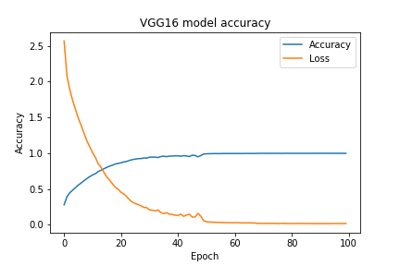

Train accuracy: 0.9998%

Test accuracy: 0.4045%

Own ResNet50:

Classification report:

precision recall f1-score support

antelope 0.68 0.58 0.63 106

bat 0.70 0.38 0.49 37

beaver 0.28 0.68 0.39 19

bobcat 0.75 0.69 0.72 74

buffalo 0.65 0.60 0.62 104

chihuahua 0.66 0.74 0.70 42

chimpanzee 0.75 0.62 0.68 73

collie 0.89 0.86 0.88 102

dalmatian 0.70 0.70 0.70 66

german+shepherd 0.94 0.89 0.92 133

grizzly+bear 0.86 0.77 0.81 74

hippopotamus 0.98 0.71 0.82 76

horse 0.92 0.59 0.72 168

killer+whale 0.70 0.56 0.62 25

mole 0.20 0.14 0.17 14

moose 0.44 0.78 0.56 58

mouse 0.75 0.46 0.57 26

otter 0.84 0.88 0.86 66

ox 0.59 0.78 0.67 78

persian+cat 0.72 0.89 0.80 85

raccoon 0.51 0.70 0.59 47

rat 0.58 0.83 0.68 23

rhinoceros 0.63 0.55 0.59 65

seal 0.92 0.92 0.92 105

siamese+cat 0.86 0.89 0.88 63

spider+monkey 0.45 0.86 0.60 29

squirrel 0.87 0.82 0.84 119

walrus 0.59 0.86 0.70 22

weasel 0.59 0.52 0.55 31

wolf 0.69 0.73 0.71 70

avg / total 0.76 0.73 0.73 2000

Accuracy/loss plot

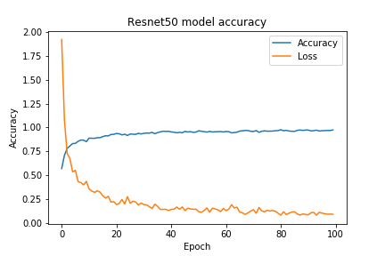

Train accuracy: 0.9737%

Test accuracy: 0.729%